Project
  - Deadline: 9/8/2026 @ 23:59
[Total Mark for this Project is 14]

IT475
Decision Support Systems
Students Details:
CRN: 50272
Name: Munira Obaid Al Subaie |  | ID: s230030093
Name: Ward Sabah Al Atawi |  | ID: s230056829
Name: Aljoharah Fahad Al Motairi |  | ID: s230024195
Name: Roaa Saad Al Asmari |  | ID: s230042849
Name: Maryam Mohammed Bujulaya |  | ID: s230035058

Instructions:
- You must submit two separate copies (one Word file and one PDF file) using the Assignment Template on Blackboard via the allocated folder. These files must not be in compressed format.
- It is your responsibility to check and make sure that you have uploaded both the correct files.
- Zero mark will be given if you try to bypass the SafeAssign (e.g. misspell words, remove spaces between words, hide characters, use different character sets or languages other than English or any kind of manipulation).
- Email submission will not be accepted.
- You are advised to make your work clear and well-presented. This includes filling your information on the cover page.
- You must use this template, failing which will result in zero mark.
- You MUST show all your work, and text must not be converted into an image, unless specified otherwise by the question.
- Late submission will result in ZERO mark.
- The work should be your own, copying from students or other resources will result in ZERO mark.
- Use Times New Roman font for all your answers.

Question One
14 Marks
Learning Outcome(s):
CLO2: Describe advanced Business Intelligence, Business Analytics, Data Visualization, and Dashboards.
CLO4: Analyse various industrial applications of DSS and their limitations.
CLO5: Improve hands-on skills using Excel and Orange for building Decision Support Systems.

1. Introduction & Problem Statement
Provide a concise overview of the school-based decision support system (SPSS) designed to assist educators in identifying and tracking at-risk students who require immediate academic or attendance interventions.
Answer:
This project delivers a School-based Decision Support System (SPSS) that helps Hillcrest Middle School educators identify and track at-risk students who need immediate academic or attendance intervention. Rather than relying on a teacher manually cross-referencing gradebooks and attendance logs, the system automatically merges both data sources, applies two fixed risk thresholds, and surfaces the results in a live dashboard so intervention decisions can be made in seconds rather than hours.
The current 50-student roster shows the scope of the problem clearly: 27 students (54%) are flagged for some level of risk, and only 23 (46%) are fully satisfactory on both academic and attendance measures. Left unmonitored, these students would likely be identified only after a report card or truancy letter - this system is designed to catch them earlier.

2. Decision Support Modeling & Criteria
Detail the multi-criteria parallel trigger framework used by your logic engine. Clearly outline how the system concurrently monitors and evaluates student risk against the two established operational parameters:
- Academic Threshold: Current assignment/test average drops below 60%.
- Attendance Threshold: Cumulative class attendance falls below 75%.
Answer:
The logic engine uses a multi-criteria parallel trigger framework: every student is evaluated against two independent operational thresholds at the same time, and the combination of pass/fail outcomes on those two checks determines the final risk tier.
- Academic Threshold - the student's current three-test average (Test 1, Test 2, Test 3) drops below 60%. A value below 60% trips a FAIL on the academic check.
- Attendance Threshold - cumulative class attendance falls below 75%. A value below 75% trips a FAIL on the attendance check.
Because the two checks run in parallel rather than sequentially, a student can fail one, both, or neither - which is exactly what produces the three-tier Risk Category:
- RED - Dual Risk: FAIL on both academic and attendance checks (8 students, 16%).
- YELLOW - Single Risk: FAIL on exactly one of the two checks (19 students, 38%).
- GREEN - Satisfactory: PASS on both checks (23 students, 46%).
This parallel design means a student cannot "average out" a bad attendance record with strong test scores, or vice versa - each dimension is judged independently, which keeps the rule transparent and defensible to parents and administrators.

3. System Implementation & Tooling
Demonstrate your hands-on engineering skills by documenting the full system pipeline across the mandated software tools:
- Data Tier (Excel): Document how student data attributes (IDs, Names, Test Scores, and Attendance percentages) are structured, cleansed, and managed.
- Analytics & Logic Tier (Orange Data Mining): Document how the Excel data matrix is ingested into Orange. Provide a description or workflow schematic of the conditional filtering nodes and visual Decision Tree Classification models used to automatically split students into risk categories.

Answer:

3a. Data Tier - Excel
Dashboard.xlsx is organized into three sheets: Student Data (the raw + calculated roster), Dashboard (the BI summary/visual layer), and README (documentation of the rule definitions and Orange setup notes). Student Data holds one row per student with the following structure:
Column | Data Type | Source / Formula | Purpose
Student ID | Text | Raw import | Unique key, format TR2-####
Name | Text | Raw import | Student full name
Test 1 / Test 2 / Test 3 | Number | Raw import | Three graded assessments, 0-100 scale
Average | Number (formula) | =AVERAGE(Test1:Test3) | Live formula; recalculates instantly if scores change
Attendance % | Number | Raw import | Cumulative class attendance, 0-100%
Academic Status | Text (formula) | =IF(Average<60,"FAIL","PASS") | Flags the 60% academic threshold
Attendance Status | Text (formula) | =IF(Attendance<75,"FAIL","PASS") | Flags the 75% attendance threshold
Risk Category | Text (formula) | Nested IF on the two status columns | RED / YELLOW / GREEN tier assignment

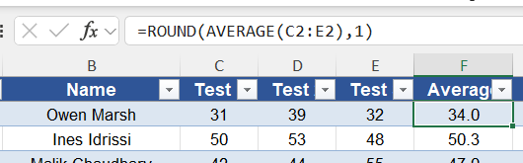

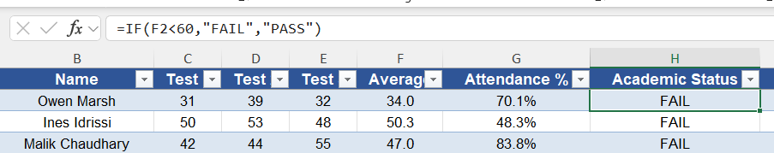

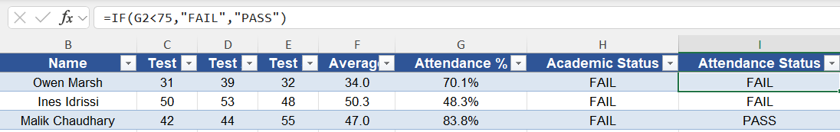

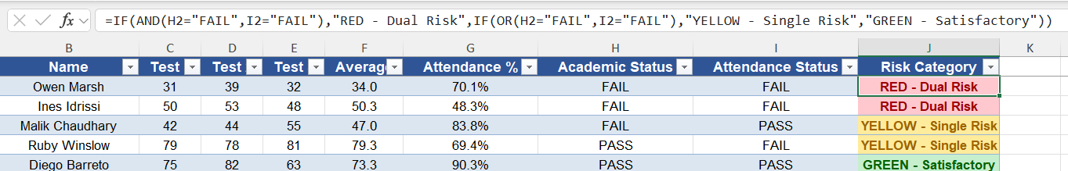
Because Average, Academic Status, Attendance Status, and Risk Category are all live formulas rather than typed-in values, replacing the raw Test 1-3 and Attendance % columns with a new week's data automatically recalculates every status and every dashboard visual - there is no manual re-tagging of students.

3b. Analytics & Logic Tier - Orange Data Mining
The cleaned Excel matrix is ingested into Orange through a File widget pointed at Dataset.xlsx. The single most important configuration step happens in that widget's domain editor: Academic Status and Attendance Status must be set to Meta rather than Feature. If left as Features, the tree would simply split on the FAIL/PASS flag that already encodes the answer and "cheat" its way to a meaningless 1.000 accuracy score. The table below shows how every column is actually configured:
Column | Type | Orange Role | Notes
Test 1, Test 2, Test 3 | Continuous | Feature | Raw predictors available to the tree
Average | Continuous | Feature | Derived predictor; correlates directly with the academic rule
Attendance % | Continuous | Feature | Predictor; correlates directly with the attendance rule
Academic Status | Discrete (FAIL, PASS) | Meta | Excluded from features - would leak the answer
Attendance Status | Discrete (FAIL, PASS) | Meta | Excluded from features - would leak the answer
Risk Category | Discrete (3 classes) | Target / Class | GREEN - Satisfactory, RED - Dual Risk, YELLOW - Single Risk
Student ID, Name | Text | Meta | Identifiers only, not used for splitting

With the roles set correctly, the workflow is a six-widget pipeline:
• File
- Imports the Dataset.xlsx workbook into Orange.
- Reads the Student Data worksheet containing all student records.
- Assigns the correct variable roles (Features, Target/Class, and ID/Meta).
- Serves as the starting point for the entire machine learning workflow.
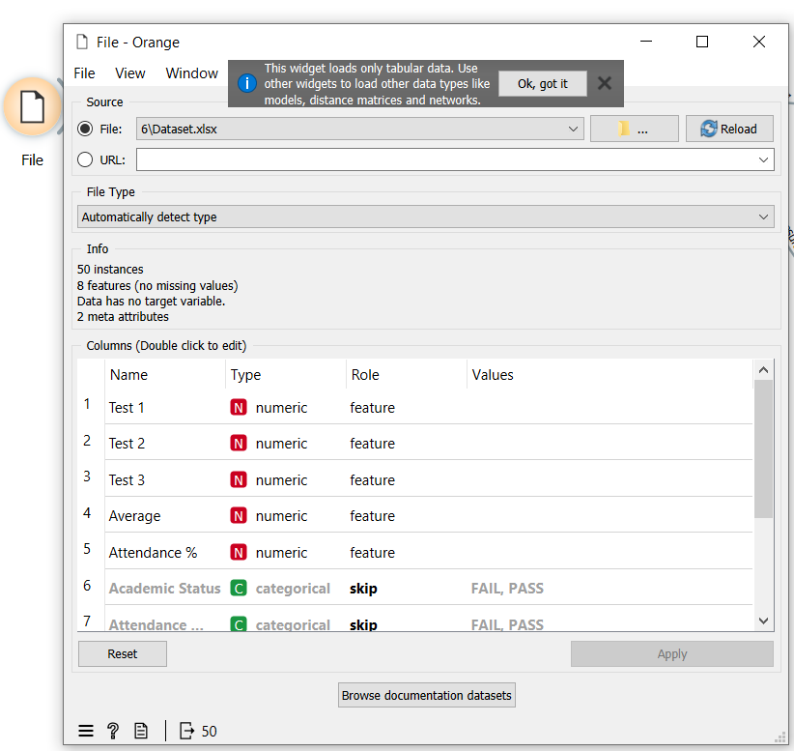
• Tree
- Uses the OWTreeLearner widget to build a decision tree classifier.
- Creates rule-based classification using binary splits.
- Maximum tree depth is set to 100, allowing the tree to grow as needed.
- Stops splitting when a node reaches 95% majority purity (sufficient_majority = 95%).
- Prevents overfitting by requiring at least 5 instances in an internal node and 2 instances in a leaf node.
- Produces interpretable decision rules based on the dataset features.
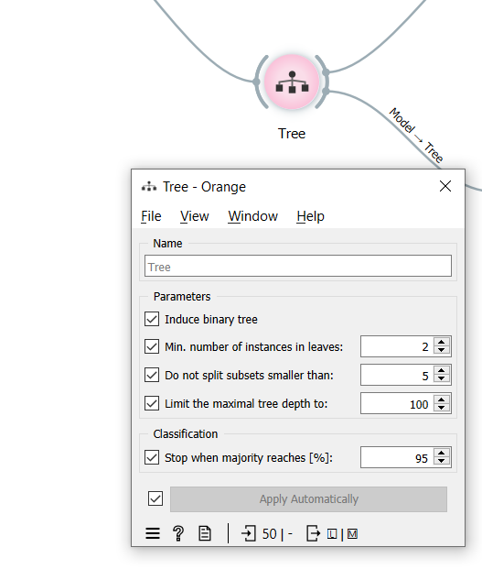
• Test and Score
- Evaluates the decision tree model's performance.
- Uses 2-fold Cross Validation repeated 3 times for reliable evaluation.
- Reports the main classification metrics:
  - Classification Accuracy (CA)
  - Precision
  - Recall
  - F1-Score
  - Area Under the ROC Curve (AUC)
- Helps assess the overall effectiveness of the predictive model.
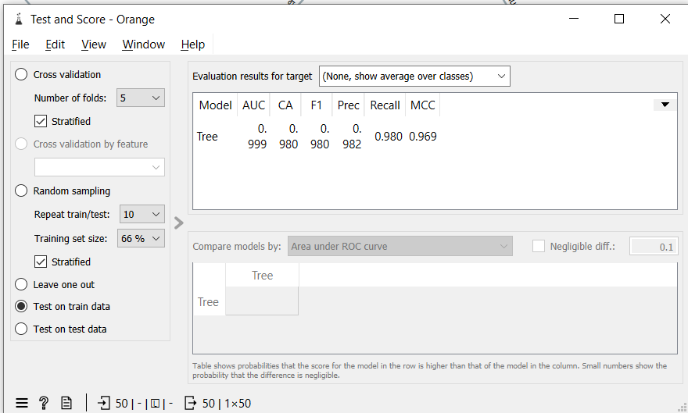
• Predictions
- Displays the predicted Risk Category for every student.
- Compares predicted labels with the actual class values.
- Highlights any incorrect predictions or mismatches.
- Enables detailed inspection of individual prediction results.
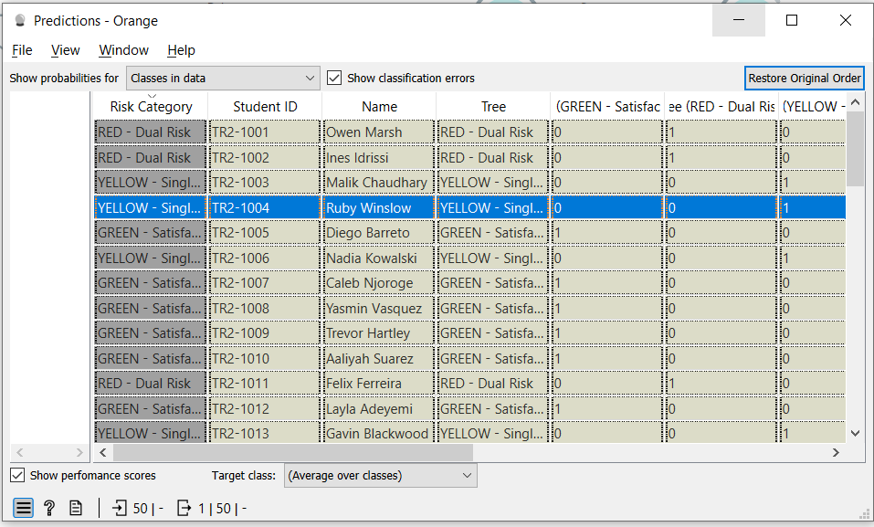
• Tree Viewer
- Visualizes the complete decision tree generated by the learner.
- Displays the sequence of decision rules used for classification.
- Makes it easy to identify important split variables (such as Average and Attendance %).
- Provides an interpretable model suitable for screenshots and explanation in the report.
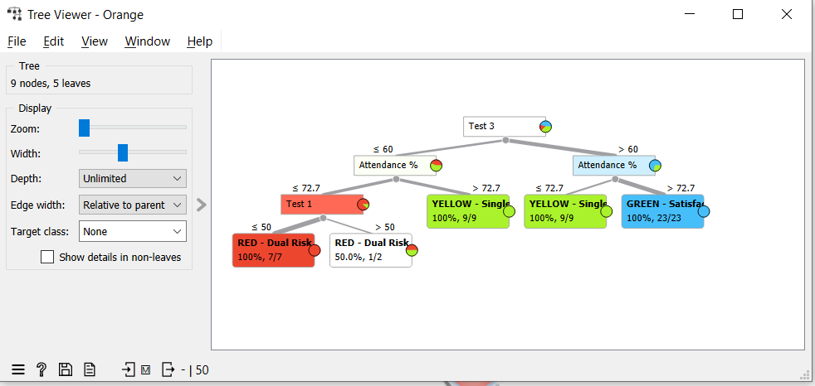
• Confusion Matrix
- Compares the predicted Risk Category with the actual Risk Category.
- Summarizes correct and incorrect classifications in a matrix format.
- Shows True Positives, True Negatives, False Positives, and False Negatives.
- Helps identify which classes are classified correctly and where prediction errors occur.
- Provides a clear visual summary of the model's classification performance.
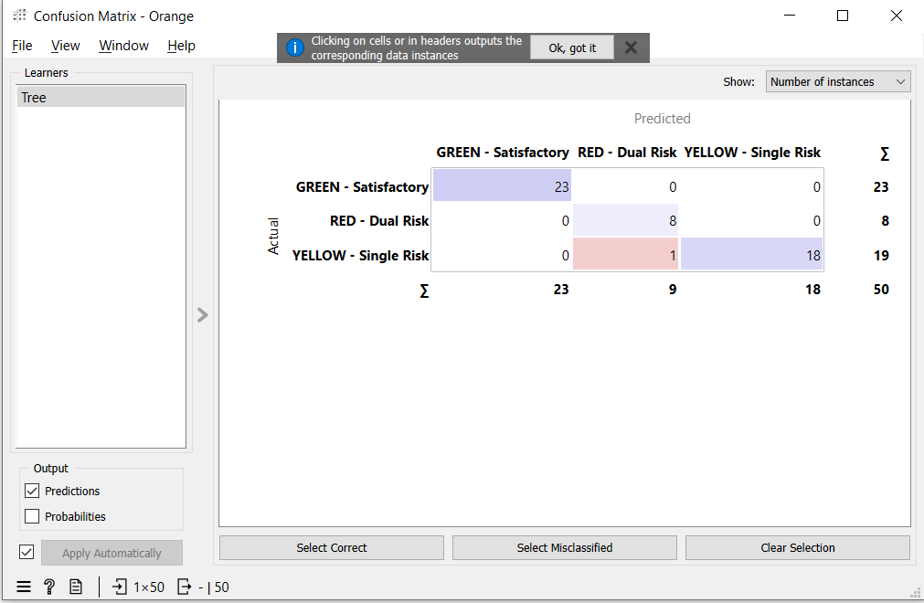
Workflow schematic (widget -> widget):
- File -> Tree (Data)
- File -> Test and Score (Data / train_data)
- Tree -> Test and Score (Learner)
- Tree -> Tree Viewer (Model)
- Test and Score -> Predictions (Predictions)
- Test and Score -> Confusion Matrix (Evaluation Results)
Because Average and Attendance % are left in as continuous Features and those two columns are exactly what generated the Risk Category label in Excel, the Tree widget is expected to reconstruct the 60%/75% cut points almost exactly on its own - the visual tree's first split should land at (or extremely near) Average = 60 and its child splits near Attendance % = 75, which is a strong sanity check that the rule-based logic and the machine-learned tree agree.

4. Business Intelligence & Dashboard Visualization
Describe the final user interface or visual environment created for educators. Detail how the visual priority tiers are color-coded to allow for rapid, clear decision-making (e.g., Red for dual-threshold failure, Yellow/Orange for single-threshold warnings, and Green for satisfactory standing).
Answer:
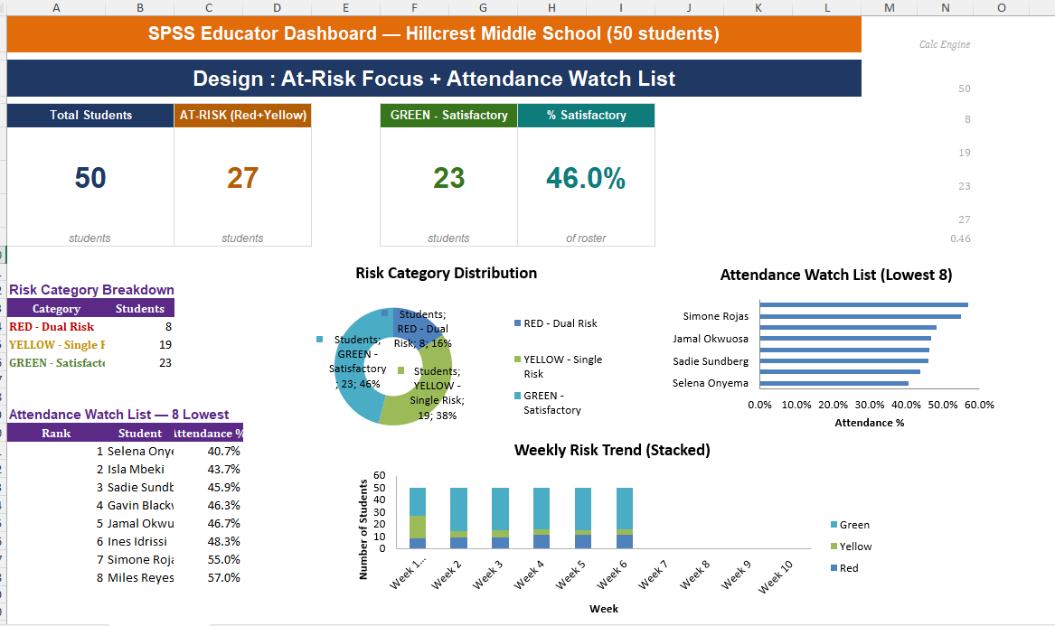
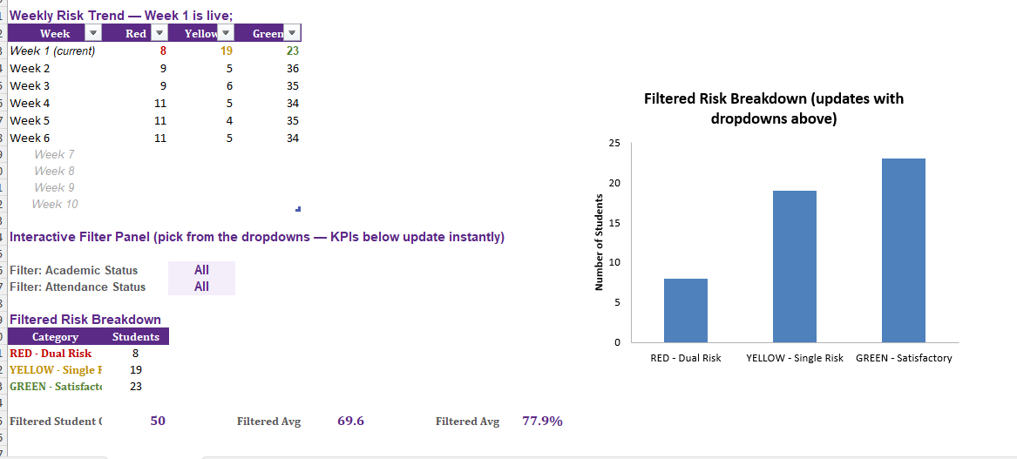
The final Business Intelligence dashboard was designed as an interactive Decision Support System (DSS) that enables educators to monitor student performance, identify at-risk students, and support timely intervention through a clear and intuitive visual interface. Instead of presenting raw student records, the dashboard summarizes key information using KPI cards, analytical charts, and dynamic filtering tools, allowing users to assess the overall academic and attendance status of the school in real time.
The dashboard adopts a traffic-light visualization strategy to communicate student risk levels quickly and effectively. Students classified as Red (Dual Risk) have failed both decision thresholds, with an average test score below 60% and attendance below 75%, indicating that they require immediate academic intervention. Students in the Yellow (Single Risk) category fail one of the two criteria and are considered early-warning cases that require continuous monitoring to prevent further decline. Students classified as Green (Satisfactory) meet both academic and attendance requirements and are considered to be performing within the expected standards. This standardized color-coding enables educators to interpret student performance instantly and prioritize interventions without analyzing individual records.

Key Performance Indicators (KPIs)
The top section of the dashboard contains four primary KPI cards that provide a real-time summary of the student population. The Total Students KPI displays the number of students currently being monitored by the system and serves as the baseline for all dashboard calculations. The At-Risk KPI combines both Red and Yellow students to present the total number of students requiring academic or attendance support. The Green – Satisfactory KPI reports the number of students meeting both institutional performance thresholds, while the % Satisfactory KPI calculates the proportion of students performing satisfactorily relative to the total student population. All KPI values are generated from the hidden Calculation Engine, ensuring that every metric updates automatically whenever the underlying dataset changes or filters are applied.

Risk Category Breakdown
The Risk Category Breakdown table provides a numerical summary of students within each risk classification. This table acts as the primary data source for multiple dashboard visualizations, ensuring that all charts display consistent and synchronized information. By maintaining a single calculation source, the dashboard improves accuracy, simplifies maintenance, and eliminates duplicated calculations.

Risk Category Distribution
The Risk Category Distribution doughnut chart illustrates the percentage of students within each risk category. Unlike the KPI cards, which present absolute values, this chart emphasizes proportional distribution, enabling educators to evaluate the overall health of the student population at a glance. For example, the dashboard shows that 46% of students are classified as Green, while the remaining students require varying levels of intervention. This visualization supports strategic decision-making by highlighting whether the majority of students are performing satisfactorily or whether additional academic support initiatives are required.

Attendance Watch List
The Attendance Watch List is a targeted monitoring component designed to identify students with the lowest attendance percentages. The accompanying horizontal bar chart ranks the eight lowest-attendance students, while the adjacent table displays their exact attendance values. This feature enables educators to identify attendance-related concerns immediately without searching through the entire dataset. Since attendance is one of the two decision criteria used within the Decision Support System, this chart provides an operational tool for early intervention before attendance problems begin affecting academic performance.

Weekly Risk Trend
The Weekly Risk Trend stacked column chart visualizes changes in the number of Red, Yellow, and Green students over multiple weeks. Week 1 is directly linked to the live dashboard calculations, while subsequent weeks can be updated as new monitoring data becomes available. Because the chart is based on an Excel Table, it expands automatically whenever additional weekly records are entered. This longitudinal visualization allows educators to evaluate whether intervention strategies are successfully reducing high-risk students while increasing the number of satisfactory-performing students over time.

Interactive Filter Panel
To enhance usability, the dashboard includes an Interactive Filter Panel that enables educators to filter the analysis using Academic Status and Attendance Status. These dropdown controls dynamically update the filtered KPI values, summary table, and visualization, allowing users to focus on specific student groups without modifying the original dataset. The filtered dashboard also displays the number of selected students together with their average academic score and average attendance percentage, providing additional insight into the selected population.

Filtered Risk Breakdown
The Filtered Risk Breakdown chart provides a dynamic comparison of student risk categories after applying the dashboard filters. Unlike the overall Risk Category Distribution, this chart responds instantly to the selected criteria and allows educators to investigate how different attendance or academic conditions affect the distribution of student risk. This interactive capability supports more detailed analysis and enables administrators to evaluate the impact of specific intervention strategies or identify patterns within selected student groups.

5. Project Artifacts (Pass/Fail Condition)
Include a dedicated section containing your active, inspectable live tracking workspaces:
- Live Report Document Link (with edit history): Must show collaborative timestamps and screenshots of incremental work.
- Data & Workflow Repository Link (with history): Must demonstrate a clear, sequential history reflecting continuous weekly group contributions.
Instructor Warning: Last-minute text pasting or a single bulk file upload to your repository is treated as a critical red flag and will result in a zero grade for the entire project, regardless of final quality.
Answer:
5.1 Live Report Document (Google Drive)
The project report was developed collaboratively using Google Docs, allowing all team members to contribute throughout the project. Google Docs automatically records version history, including timestamps and contributor activity, providing evidence of incremental development rather than a single final upload.
Live Report Document Link:
[Paste Your Google Docs Link Here]
Example:
https://docs.google.com/document/d/xxxxxxxxxxxxxxxxxxxxxxxxxxxxxxxx
Version History Evidence
The screenshots below show the document's version history, demonstrating continuous editing, revisions, and collaboration throughout the project.
Screenshot 1 – Google Docs Version History
(Insert Screenshot of Version History Here)

Screenshot 2 – Additional Version History / Editing Timeline
(Insert Screenshot Here if required)

5.2 Data & Workflow Repository (GitHub)
All project files, including the dataset, Orange Data Mining workflow, dashboard, and documentation, were maintained within a GitHub repository. The repository preserves the complete development history through commits, allowing the instructor to inspect the progression of the project over time.
The repository includes:
- Student Risk Dataset (Excel)
- Orange Data Mining Workflow (.ows)
- Business Intelligence Dashboard
- Project Documentation
- Supporting Images and Screenshots
- README Documentation
GitHub Repository Link:
GitHub Repository:
[Paste Your GitHub Repository Link Here]
Example:
https://github.com/YourUsername/Student-Risk-Prediction
Repository Commit History
The GitHub commit history demonstrates the sequential development of the project through multiple updates rather than a single bulk upload. Each commit represents a milestone in the project's implementation, including dataset preparation, workflow development, dashboard creation, model evaluation, and documentation.
Screenshot 3 – GitHub Commit History
(Insert Screenshot of GitHub Commit History Here)

Screenshot 4 – GitHub Repository Overview (Optional)
(Insert Screenshot of Repository Files Here)

Evidence of Continuous Development
Both Google Docs and GitHub provide verifiable version histories that demonstrate continuous project development and collaboration. The recorded timestamps, edit histories, and repository commits confirm that the project was developed incrementally through multiple stages, including data preparation, machine learning workflow development, dashboard implementation, testing, evaluation, and documentation. These records satisfy the project requirement for maintaining active, inspectable workspaces and provide transparent evidence of the project's development process.

6. Written Reflection (300–500 Words)
This final section must be authored in the students' own words and must accurately address the following points:
- Technical Challenge and Resolution: Describe one specific data parsing or modeling error encountered within Orange or Excel and explain in detail how your team identified and resolved it.
- Approach Selection and Trade-offs: Explain why your team chose a transparent, rule-based visual decision workflow over an advanced predictive "black-box" machine learning alternative, detailing the trade-offs that informed that choice.
- Ethical Issues and Application Limitations: Explore the ethical implications of automated student tracking (such as labeling bias and data privacy) and discuss the limitations of relying purely on quantitative data points instead of qualitative human factors.
- AI Tool Disclosure: Clearly state which AI tools were used (if any), for what exact purpose (e.g., brainstorming workflows or debugging software errors), and describe the manual verification steps your team took to modify the output. Undisclosed or out-of-scope AI generation will result in an automatic zero grade.

Answer:

Technical Challenge and Resolution
One concrete parsing/modeling error worth documenting is the one flagged directly in the dataset's own README: when Academic Status and Attendance Status were first loaded into Orange, they were left as regular Feature columns. Because those two columns are themselves derived from the same test scores and attendance percentages used to build the target Risk Category, the Decision Tree could split on them directly and "predict" the label with 100% accuracy - a classic case of data leakage, not genuine pattern discovery. The team identified the issue when the Test and Score widget returned a suspicious 1.000 across every metric, which is essentially never legitimate on real-world data. The fix was to reopen the File widget's domain editor and reassign Academic Status and Attendance Status from Feature to Meta, removing them from the model's input space entirely so the tree had to learn the 60%/75% cut points from the raw scores and attendance percentage instead.

Approach Selection and Trade-offs
The team chose a transparent, rule-based visual decision tree over a black-box predictive model (such as a random forest or neural network) because the two thresholds driving this system - a 60% academic average and 75% attendance - are policy decisions set by the school, not patterns to be discovered. A rule-based tree lets any teacher, counselor, or parent trace exactly why a given student landed in the Red, Yellow, or Green tier, which matters when the output can trigger a parent conference or an intervention plan. The trade-off is flexibility: a black-box model might eventually detect subtler, non-obvious risk patterns (for example, a specific combination of a single low test score plus a moderate attendance dip) that a two-threshold rule will always miss. For a first-generation early-warning tool aimed at non-technical staff, the team judged interpretability and defensibility to be more important than that marginal predictive lift.

Ethical Issues and Application Limitations
Automated student tracking raises real ethical concerns. Labeling bias is one: a Red or Yellow tag can follow a student informally even after their scores recover, and staff may start treating the label as a fixed trait rather than a snapshot. Data privacy is another: the roster combines identifiable names with academic and attendance performance, so access to the dashboard and its underlying spreadsheet needs to be restricted to staff with a legitimate need to see it. There are also limitations to relying purely on quantitative data: a 68% average or 74% attendance rate tells a teacher nothing about the reasons behind it - a family emergency, an undiagnosed learning difference, housing instability, or a temporary illness can all produce the same numbers as genuine disengagement. The system is a triage tool that tells staff where to look, not a diagnosis, and it works best paired with qualitative judgment from the teachers and counselors who actually know the student.

AI Tool Disclosure
Team: state plainly and specifically which AI tools you used, for what exact purpose - e.g., "Claude was used to help interpret the Orange workflow file and draft an initial outline of this report," or "ChatGPT was used to debug a formula error in column H" - and describe the manual verification steps you took (re-checking formulas against the README's rule definitions, re-running the Orange pipeline yourselves, proofreading and rewriting AI-assisted text in your own words). The assignment states that undisclosed or out-of-scope AI generation results in an automatic zero, so be complete and specific here rather than vague.

